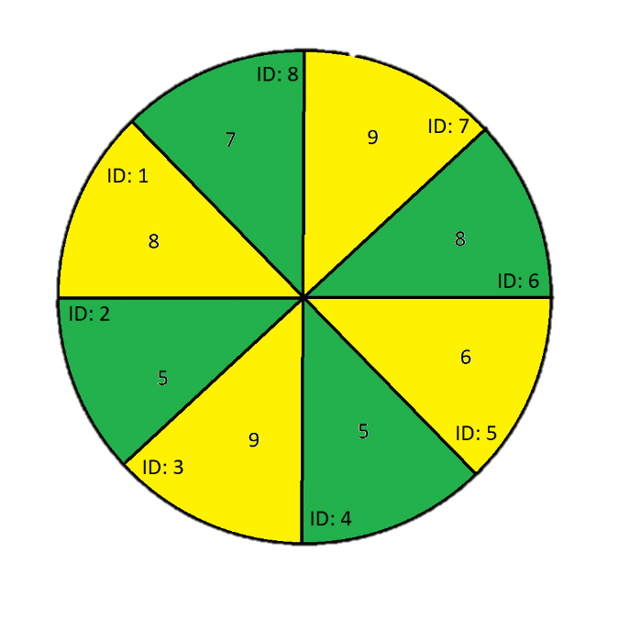1)

The human will choose one of the highest numbers, so ID 3 or 7, both of which are 9. Let’s assume ID 3. The Computer then picks the highest slice unless two are available, in which the lowest ID will be selected (ID2). The user then selects ID1. This will carry on in this fashion until the total scores of Human 32, Computer 25. As coincidental visual aid, the Human would choose the Yellows, and the Computer, the greens.

This obviously is not optimal as it does not maximise the amount of cake the computer could get. Oddly enough, in the example to the left, the results would not change as the starting choice (ID:3) would always be surrounded with 5’s that the computer would have to eat.

2)   
Please see the attached files

3)

N = pieces, 0(n^2) This is due to no recursion call being needed more than once as it is saved in cache.

4)

The computer would first choose the biggest number with the biggest numbers around it. Also, in in the picker function (as the list given would be even) the third base case would need to be y==x+2

README:

Test lots is not functioning correctly; it needs clicking on when it freezes for some reason, unknown. I did not spend more time trying to fix this as it wasn’t needed.